SUPLEMENTARY FILES
Attachment 1
Data Processing Results
SRTM DEM Image Data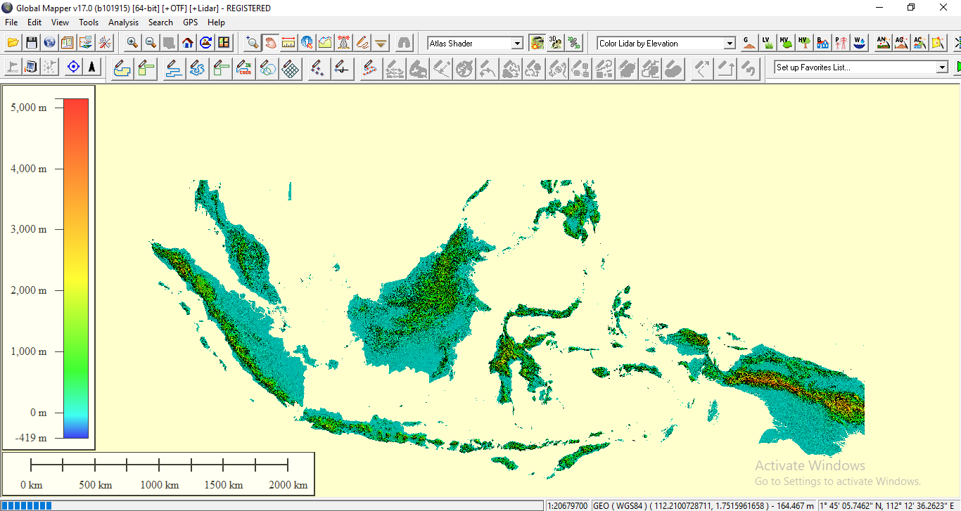
Figure i Visual Data DEM SRTM Image 90 m
Result of Data Processing Straightness Height of irradiation 90°
Gentong Mountain and Surrounds
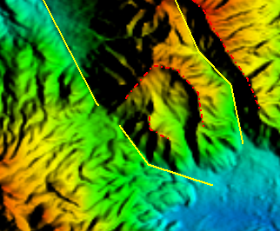
Figure ii Linearity withdrawal data and Rosette Diagram Plot Results of Gentong Mount and its surroundings

Sadakeling Mount
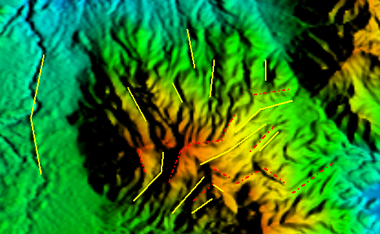 | 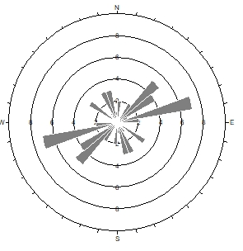
Figure iii Linearity withdrawal data and the results of the Sadakeling Mount Rosette Diagram plot
Karaha Mount or Putri Mount
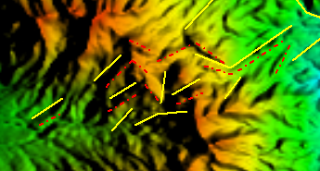 | 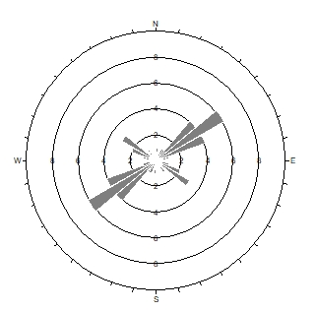
Figure iv Linearity withdrawal data and the results of the Karaha Mount Rosette Diagram plot

Jurang Mount
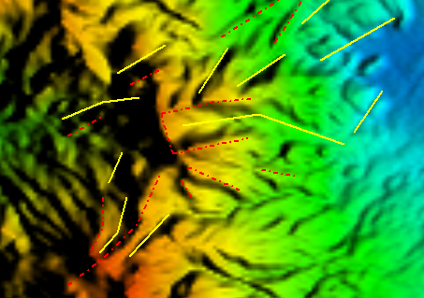 | 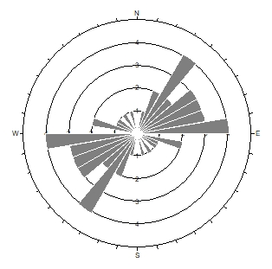
Figure v Linearity withdrawal data and the results of the Jurang Mount Rosette Diagram plot

Ngantuk Mount
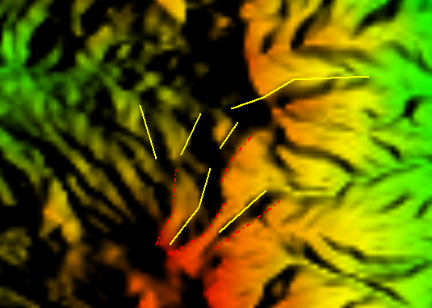 | 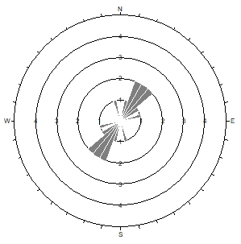
Figure vi Linearity withdrawal data and the results of the Ngantuk Mount Rosette Diagram plot

Beuti Ganar Mount
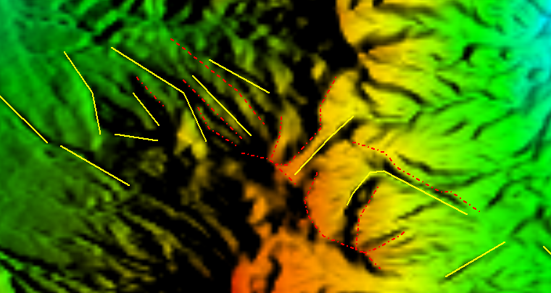 | 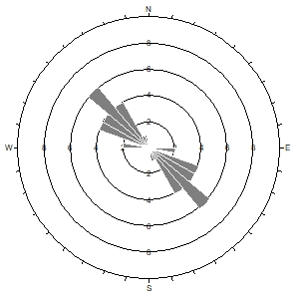
Figure vii Linearity withdrawal data and the results of the Beuti Ganar Mount Rosette Diagram plot
Talaga Bodas Mount
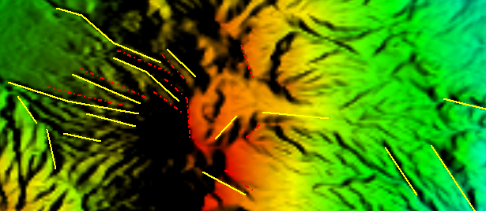 | 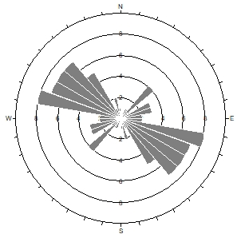
Figure viii Linearity withdrawal data and the results of the Talaga Bodas Mount Rosette Diagram plot

Galunggung Mount
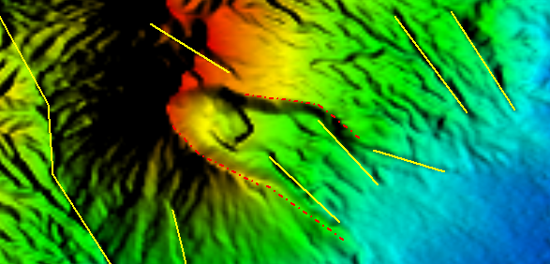 | 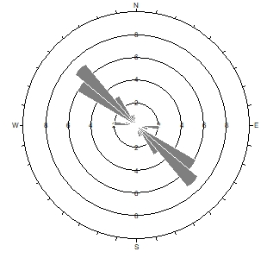
Figure ix Linearity withdrawal data and the results of the Galunggung Mount Rosette Diagram plot
Karacak Mount
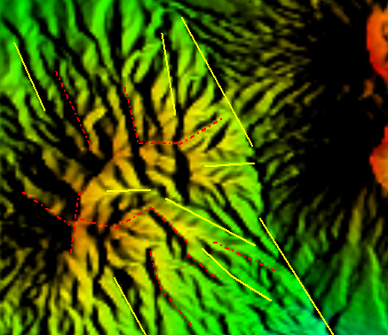 | 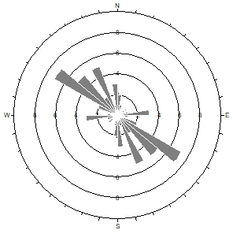
Figure x Linearity withdrawal data and the results of the Karacak Mount Rosette Diagram plot

Cross-sectional Drawing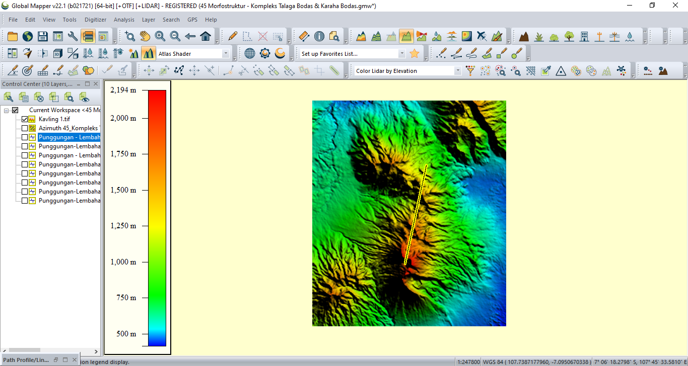
Figure xi Cross-sectional line S – N Conceptual Model of Karaha Bodas and Talaga Bodas . Fields

Attachment 2
Calculation of Hydrogeochemical Data
Talaga Bodas Field Water Chemistry Data
Location | Sample Code | pH | Li | Na | K | Ca | Mg | B | F | Cl | SO₄ | HCO₃ | CO₃
Talaga Bodas 1 | TB 1 | 4,77 | 0,001 | 25,5 | 4,85 | 185 | 33,3 | 0,528 | 0,18 | 3716 | 304 | 17,7 | 0
Talaga Bodas 2 | TB 2 | 3,43 | 0,001 | 25,4 | 4,85 | 190 | 44,5 | 0,46 | 0,264 | 32,8 | 419 | 0 | 0
Talaga Bodas 3 | TB 3 | 3,35 | 0,001 | 25,4 | 4,74 | 180 | 43,2 | 0,45 | 0,334 | 28 | 377 | 0 | 0
Ciengang Atas | TB 4 | 2,6 | 0,001 | 71,1 | 19 | 225 | 66,4 | 1,58 | 0,5 | 654 | 309 | 0 | 0
Ciengang Bawah | TB 5 | 2,99 | 0,001 | 49,8 | 12,8 | 153 | 48,5 | 1,05 | 0,543 | 385 | 299 | 0 | 0
Cipusaka 1 | TB 6A | 2,94 | 0,001 | 68,1 | 11,5 | 272 | 73,5 | 0,699 | 0,5 | 187 | 490 | 0 | 0
Cipusaka 2 | TB 6B | 2,94 | 0,001 | 48,2 | 9,17 | 203 | 44,5 | 0,404 | 0,456 | 135 | 474 | 0 | 0
Pancuran 7 | TB 7 | 2,99 | 0,001 | 47,6 | 17,1 | 195 | 51,9 | 1,93 | 1,29 | 523 | 384 | 0 | 0
Cirohmat | TB 8 | 2,65 | 0,001 | 28,3 | 8,71 | 175 | 32,7 | 0,71 | 0,41 | 228 | 366 | 0 | 0
Ciateuh | TB 9 | 1,99 | 0,001 | 72,6 | 25,9 | 278 | 93,4 | 2,66 | 1,37 | 744 | 381 | 0 | 0
advanced
Location | Sample Code | H⁺ | SiO₂ | NH₄ | As | Sr | Ba | Fe | Mn | Cond  umhos/cm | Kation | Anion | Charge  Balance
Talaga Bodas 1 | TB 1 | 0 | 10,9 | 2,11 | 0,0058 | 0,001 | 0,001 | 0,01 | 0,458 | 683 | 13,34 | 111,46 | 79%
Talaga Bodas 2 | TB 2 | 0,32 | 10,3 | 2,82 | 0,0015 | 0,001 | 0,001 | 0,366 | 0,4 | 903 | 14,91 | 9,66 | 21%
Talaga Bodas 3 | TB 3 | 0,44 | 13,38 | 2,46 | 0,0009 | 0,001 | 0,009 | 0,01 | 0,562 | 999 | 14,34 | 8,66 | 25%
Ciengang Atas | TB 4 | 3,44 | 16,7 | 4,93 | 0,022 | 0,001 | 0,011 | 14,1 | 0,133 | 341 | 23,54 | 24,91 | 3%
Ciengang Bawah | TB 5 | 1,6 | 13,8 | 2,82 | 0,035 | 0,001 | 0,001 | 16,7 | 1,09 | 1990 | 15,89 | 17,11 | 4%
Cipusaka 1 | TB 6A | 1,74 | 15,4 | 5,98 | 0,015 | 0,001 | 0,014 | 22,5 | 0,412 | 1943 | 25,15 | 15,50 | 24%
Cipusaka 2 | TB 6B | 1,56 | 12,6 | 2,11 | 0,014 | 0,001 | 0,001 | 9,36 | 1,32 | 1682 | 17,71 | 13,70 | 13%
Pancuran 7 | TB 7 | 13,7 | 12,3 | 4,22 | 0,279 | 0,001 | 0,009 | 26,5 | 0,2 | 8270 | 18,71 | 22,82 | 10%
Cirohmat | TB 8 | 2,75 | 14,4 | 3,17 | 0,48 | 0,001 | 0,001 | 10,3 | 389 | 1973 | 15,64 | 14,07 | 5%
Ciateuh | TB 9 | 14,1 | 14,5 | 6,69 | 0,787 | 0,001 | 0,015 | 9,61 | 0,064 | 9200 | 34,25 | 28,99 | 8%
Lampiran i Talaga Bodas Field Water Chemistry Data
(Source : Nurohman et al., 2016)

Karaha Bodas Field Water Chemistry Data
Sample Code | Res stm frac | Concentration (ppm) |  |  |  |  |  |  |  |  | T-nkc °C | T-nkcm °C | T-qtz °C | T-anh °C
 |  | Na | K | Ca | Mg | Li | B | Si | Cl | SO₄
KRH 2-1ST | 7 | 424 | 52 | 3,7 | 0,31 | 0,72 | 33 | 348 | 534 | 128 | 228 | 227 | 223 | 300
KRH 3-1B | 15 | 497 | 96 | 2,6 | 0,018 | 1,68 | 43.4 | 541 | 826 | 58 | 268 | 268 | 267 | unsat
KRH 4-1A | 70 | 1313 | 201 | 24,8 | 0,039 | 3,82 | 105,8 | 391 | 2247 | 29 | 248 | 247 | 233 | 260
KRH 4-1B | 74 | 1251 | 188 | 24 | <0,0042 | 3,51 | 103,4 | 365 | 2107 | 27 | 245 | 245 | 227 | 262
KRH 4-1C | 67 | 1428 | 230 | 42,6 | 0,21 | 4,07 | 110 | 402 | 2450 | 22 | 247 | 247 | 236 | 255
KRH 5-1A | 22 | 2983 | 832 | 675 | 0,92 | 24,24 | 102,4 | 110 | 6906 | 20 | 272 | 271 | 143 | 220
KRH 5-1B | 34 | 2983 | 999 | 726 | 1,03 | 27,96 | 1,05 | 528 | 7014 | 14 | 285 | 285 | 264 | 232
KRH 5-1C | 11 | 3547 | 1069 | 929 | 2,31 | 19,56 | 129,4 | 70 | 8033 | 3,6 | 278 | 278 | 118 | 287
K-33a | 25 | 140 | 35 | 4,7 | 0,34 | 0,1 | 3,1 | 273 | 35 | 57 | 249 | 239 | 203 | unsat
K-33b | 25 | 133 | 34 | 3,9 | 0,75 | 0,13 | 3 | 331 | 38 | 84 | 251 | 211 | 219 | unsat
Lampiran ii Karaha Bodas Field Water Chemistry Data
(source : Powell et al., 2001)

Cipacing potential Water Chemistry Data
Sample Code | pH | Concentration (ppm)
 |  | Na | K | Ca | Mg | Li | B | SiO₂ | Cl | SO₄ | HCO₃ | NH₄ | As
Cipacing, K=25 | 6,64 | 234 | 58 | 65,8 | 65,8 | 2,5 | 5 | 155,0 | 179 | 0 | 1013 | 1,0 | 0,04
Cipacing, K-27 | 7,13 | 158 | 40 | 54,2 | 54,2 | 1,33 | 9 | 124,0 | 118 | 7 | 772 | 0,6 | 0,04
Cipacing | 8,98 | 220 | 60 | 1,6 | 1,6 | 0,46 | 6 | 137,0 | 173 | 21 | 688 | 0 | 0
Cipacing (1) | 7,45 | 210 | 72 | 70,4 | 70,4 | 1,58 | 5 | 138,7 | 160 | 2 | 799 | 1,1 | 0
Pamoyanan (1) | 7,05 | 167 | 54 | 83,4 | 83,4 | 1,42 | 2 | 143,1 | 116 | 2 | 709 | 2,6 | 0,06
Lampiran iii Cipacing and Pamoyanan potential Water Chemistry Data
(source : Direktorat Panas Bumi et al., 2017)

Talaga Bodas Field Geothermometer Data
Sample Name | Amorphous Silica | Alpha Cristobalite | Beta Cristobalite | Chalcedony conductive | Quartz conductive | Quartz adiabatic
Talaga Bodas 1 | -63 | -6 | -48 | 9 | 41 | 50
Talaga Bodas 2 | -65 | -8 | -50 | 8 | 39 | 48
Talaga Bodas 3 | -58 | 1 | -42 | 16 | 48 | 56
Ciengang Atas | -51 | 8 | -36 | 24 | 57 | 63
Ciengang Bawah | -57 | 2 | -41 | 18 | 50 | 57
Cipusaka 1 | -54 | 5 | -38 | 21 | 54 | 60
Cipusaka 2 | -59 | -1 | -44 | 14 | 46 | 54
Pancuran 7 | -60 | -2 | -45 | 14 | 45 | 53
Cirohmat | -56 | 3 | -40 | 19 | 51 | 58
Ciateuh | -56 | 3 | -40 | 19 | 51 | 59
Lampiran iv Silica Geothermometer Value in Celcius
(sources : Tom Powell & William, 2010)

advanced
Sample Name | Na-K-Ca | Na-K-Ca Mg corr | Na/K Fournier 1979 | Na/K Truesdell 1976 | Na/K Giggenbach 1988 | Na/K Tonani 1980 | Na/K Nieva & Nieva 1987 | Na/K Arnorsson 1983 | K/Mg Giggenbach 1986
Talaga Bodas 1 | 22 | 22 | 279 | 269 | 289 | 315 | 265 | 271 | 40
Talaga Bodas 2 | 22 | 22 | 280 | 270 | 290 | 316 | 265 | 272 | 37
Talaga Bodas 3 | 22 | 22 | 277 | 266 | 288 | 312 | 263 | 269 | 37
Ciengang Atas | 64 | 64 | 319 | 325 | 325 | 379 | 303 | 323 | 61
Ciengang Bawah | 56 | 56 | 314 | 318 | 321 | 371 | 299 | 316 | 55
Cipusaka 1 | 46 | 46 | 266 | 252 | 278 | 296 | 252 | 255 | 49
Cipusaka 2 | 42 | 42 | 279 | 269 | 289 | 315 | 265 | 271 | 49
Pancuran 7 | 60 | 60 | 358 | 384 | 360 | 448 | 342 | 376 | 61
Cirohmat | 38 | 38 | 337 | 352 | 341 | 410 | 321 | 347 | 51
Ciateuh | 69 | 64 | 357 | 383 | 359 | 446 | 341 | 374 | 64
Lampiran v Geothermometer Values in Celcius
(sources : Tom Powell & William, 2010)

Karaha Bodas Field Geothermometer Data
Sample Name | Na-K-Ca | Na-K-Ca Mg corr | Na/K Fournier 1979 | Na/K Truesdell 1976 | Na/K Giggenbach 1988 | Na/K Tonani 1980 | Na/K Nieva & Nieva 1987 | Na/K Arnorsson 1983 | K/Mg Giggenbach 1986
KRH 2-1ST | 228 | 227 | 235 | 211 | 249 | 249 | 222 | 217 | 167
KRH 3-1B | 268 | 268 | 281 | 271 | 291 | 318 | 266 | 273 | 262
KRH 4-1A | 247 | 247 | 256 | 238 | 269 | 280 | 242 | 243 | 283
KRH 4-1B | 245 | 245 | 255 | 236 | 267 | 278 | 241 | 241 | 355
KRH 4-1C | 246 | 246 | 262 | 245 | 273 | 288 | 247 | 249 | 243
KRH 5-1A | 271 | 271 | 324 | 333 | 330 | 389 | 309 | 330 | 273
KRH 5-1B | 285 | 285 | 348 | 369 | 352 | 430 | 332 | 362 | 281
KRH 5-1C | 278 | 278 | 334 | 348 | 339 | 406 | 319 | 343 | 261
K-33a | 249 | 239 | 311 | 313 | 318 | 366 | 295 | 312 | 151
K-33b | 251 | 212 | 313 | 317 | 320 | 370 | 298 | 315 | 137
Lampiran vi Geothermometer Values in Celcius
(sources : Tom Powell & William, 2010)

Cipacing Potential Geothermometer Data
NAMA SAMPEL | Na-K-Ca | Na-K-Ca Mg corr | Na/K Fournier 1979 | Na/K Truesdell 1976 | Na/K Giggenbach 1988 | Na/K Tonani 1980 | Na/K Nieva & Nieva 1987 | Na/K Arnorsson 1983 | K/Mg Giggenbach 1986
Cipacing, K=25 | 230 | 46 | 309 | 311 | 317 | 364 | 294 | 310 | 96
Cipacing, K-27 | 224 | 10 | 312 | 315 | 319 | 368 | 297 | 313 | 77
Cipacing | 281 | 16 | 321 | 329 | 327 | 384 | 306 | 326 | 85
Cipacing (1) | 249 | 20 | 351 | 373 | 354 | 435 | 335 | 366 | 90
Pamoyanan (1) | 238 | 26 | 344 | 363 | 348 | 423 | 329 | 357 | 86
Lampiran vii Geothermometer Values in Celcius
(sources : Tom Powell & William, 2010)

Cl/B Ratio Geoindicator Data
Sample Name | Cl | B | Cl/B
TB 1 | 3716 | 0,53 | 7037,878788
TB 2 | 33 | 0,46 | 71,30434783
TB 3 | 28 | 0,45 | 62,22222222
TB 4 | 654 | 1,58 | 413,9240506
TB 5 | 385 | 1,05 | 366,6666667
TB 6A | 187 | 0,70 | 267,5250358
TB 6B | 135 | 0,40 | 334,1584158
TB 7 | 523 | 1,93 | 270,984456
TB 8 | 228 | 0,71 | 321,1267606
TB 9 | 744 | 2,66 | 279,6992481
KRH 2-1ST | 534 | 33,00 | 16,18181818
KRH 3-1B | 826 | 43,40 | 19,03225806
KRH 4-1A | 2247 | 105,80 | 21,23818526
KRH 4-1B | 2107 | 103,40 | 20,37717602
KRH 4-1C | 2450 | 110,00 | 22,27272727
KRH 5-1A | 6906 | 102,40 | 67,44140625
KRH 5-1B | 7014 | 1,05 | 6680
KRH 5-1C | 8033 | 129,40 | 62,07882535
K-33a | 35 | 3,10 | 11,29032258
K-33b | 38 | 3,00 | 12,66666667
Cipacing, K=25 | 179,18 | 5,22 | 34,3256705
Cipacing, K-27 | 118,24 | 8,58 | 13,78088578
Cipacing | 173 | 5,6 | 30,89285714
Cipacing (1) | 159,95 | 4,65 | 34,39784946
Pamoyanan (1) | 115,9 | 2,41 | 48,09128631
Lampiran viii Cl/B ratio data in Talaga Bodas - Karaha Bodas field

Na/K Ratio Geoindicator Data
Sample Name | Na | K | Na/K
TB 1 | 26 | 4,85 | 5,257731959
TB 2 | 25 | 4,85 | 5,237113402
TB 3 | 25 | 4,74 | 5,358649789
TB 4 | 71 | 19,00 | 3,742105263
TB 5 | 50 | 12,80 | 3,890625
TB 6A | 68 | 11,50 | 5,92173913
TB 6B | 48 | 9,17 | 5,256270447
TB 7 | 48 | 17,10 | 2,783625731
TB 8 | 28 | 8,71 | 3,249138921
TB 9 | 73 | 25,90 | 2,803088803
KRH 2-1ST | 424 | 52,00 | 8,153846154
KRH 3-1B | 497 | 96,00 | 5,177083333
KRH 4-1A | 1313 | 201,00 | 6,532338308
KRH 4-1B | 1251 | 188,00 | 6,654255319
KRH 4-1C | 1428 | 230,00 | 6,208695652
KRH 5-1A | 2983 | 832,00 | 3,585336538
KRH 5-1B | 2983 | 999,00 | 2,985985986
KRH 5-1C | 3547 | 1069,00 | 3,318054256
K-33a | 140 | 35,00 | 4
K-33b | 133 | 34,00 | 3,911764706
Cipacing, K=25 | 234 | 58 | 4,041034483
Cipacing, K-27 | 158 | 40 | 3,95825
Cipacing | 220 | 60 | 3,666666667
Cipacing (1) | 210 | 72 | 2,925632472
Pamoyanan (1) | 167 | 54 | 3,073637703
Lampiran ix Na/K ratio data in Talaga Bodas - Karaha Bodas field

Sample Name | sum cations | sum anions | Charge Balance
Talaga Bodas 1 | 13,34 | 111,46 | -79%
Talaga Bodas 2 | 14,91 | 9,66 | 21%
Talaga Bodas 3 | 14,34 | 8,66 | 25%
Ciengang Atas | 23,54 | 24,91 | -3%
Ciengang Bawah | 15,89 | 17,11 | -4%
Cipusaka 1 | 25,15 | 15,50 | 24%
Cipusaka 2 | 17,71 | 13,70 | 13%
Pancuran 7 | 18,71 | 22,82 | -10%
Cirohmat | 15,64 | 14,07 | 5%
Ciateuh | 34,25 | 28,99 | 8%
KRH 2-1ST | 25,61 | 14,72 | 27%
KRH 3-1B | 32,82 | 18,82 | 27%
KRH 4-1A | 83,14 | 47,58 | 27%
KRH 4-1B | 78,94 | 44,61 | 28%
KRH 4-1C | 92,05 | 51,61 | 28%
KRH 5-1A | 246,70 | 144,29 | 26%
KRH 5-1B | 262,67 | 146,37 | 28%
KRH 5-1C | 305,43 | 167,28 | 29%
K-33a | 10,08 | 2,33 | 62%
K-33b | 9,62 | 3,16 | 51%
Cipacing, K=25 | 13,34 | 111,46 | -79%
Cipacing, K-27 | 14,91 | 9,66 | 21%
Cipacing | 14,34 | 8,66 | 25%
Cipacing (1) | 23,54 | 24,91 | -3%
Pamoyanan (1) | 15,89 | 17,11 | -4%

Charge Balance Value of Water chemistry Data
Lampiran x Charge Balance value of water chemistry data

